In this document, you will learn how to:
- Create a PM record and identify the mandatory fields under each tab of a PM record.

Create a PM Record
The purpose of Preventive Maintenance (PM) is to reduce the likelihood of equipment breakdowns or failures. It is a planned maintenance that is scheduled according to a pre-determined frequency (time-based or meter-based). A PM record is created from the Preventive Maintenance (Oil) application in Maximo.
Listed below are the steps to create a PM record in Maximo:
- Navigate to the Preventive Maintenance (Oil) application page, click the New PM icon.

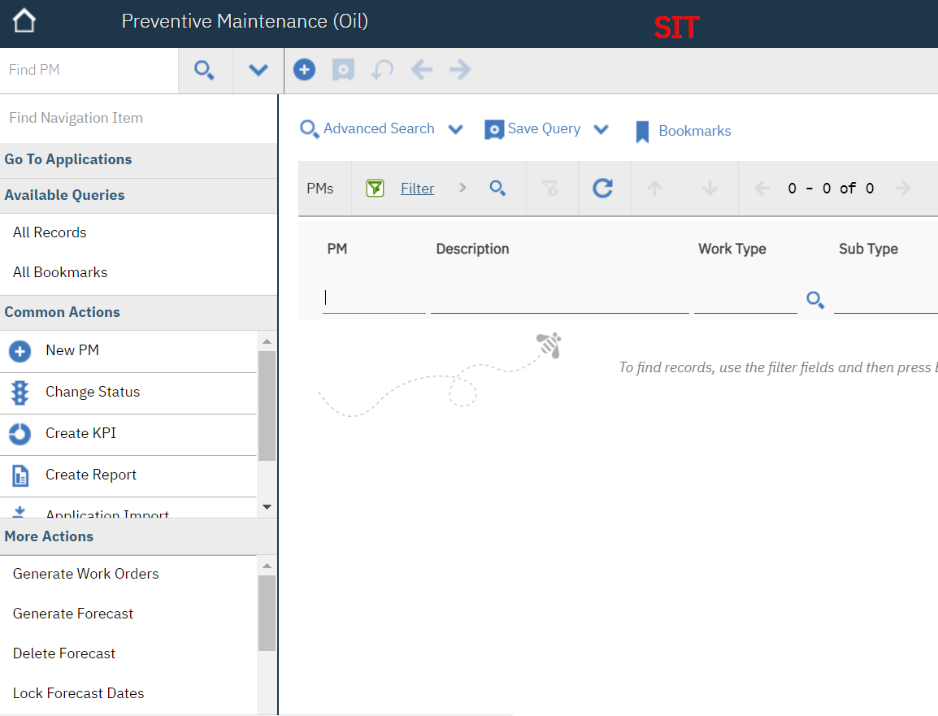
- In Locations (Oil) application, click the Application Import option under the Common Actions bar. On the PM tab, enter the details in the mandatory fields. The mandatory fields in the PM tab are:
  - PM Description
  - Location
  - Job Plan
Note: In this example, we are adding details for a Location. However, you can choose to add an Asset (if required).
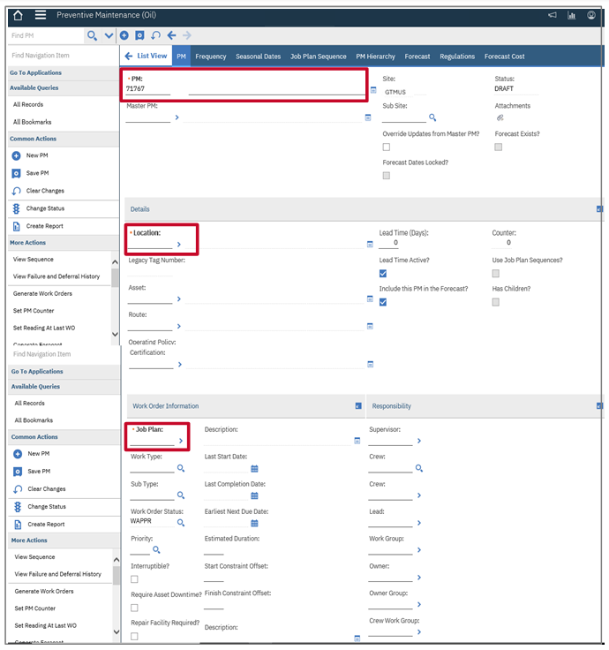

Note:
- Once the mandatory fields are populated in this tab, enter the Work Type and Sub Type for this PM record under the Work Order Information section.
- If the required value is not known for these fields, click the Select Value icon to search or filter the required Work Type and Sub Type values
- The Start Constraint Offset and Finish Constraint Offset fields are populated in hours
- Enter the Owner’s name in the Owner field for the PM that is transferred to the Work Order

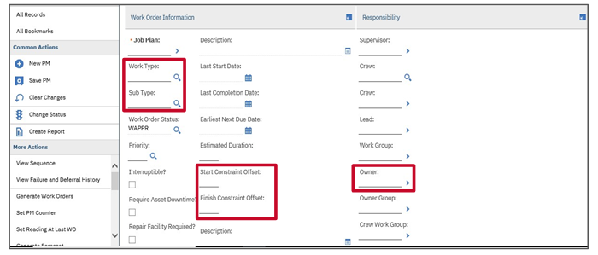

- Click the Frequency tab and enter details in the mandatory fields.
Notes: The mandatory fields in the Frequency tab are:
- Frequency
- Frequency Units
The PM number field remains a pre-populated mandatory field for all tabs.
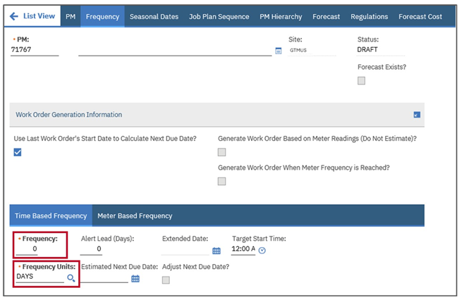
Note: You can add more information to the PM record in Maximo using the below mentioned tabs. All mandatory fields that show up on these tabs come from the Primary tab and do not need to be refilled out there.

- Browse for the file and click Open.
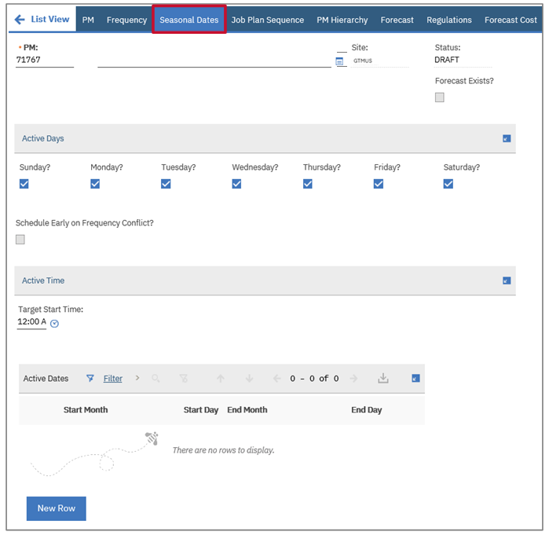

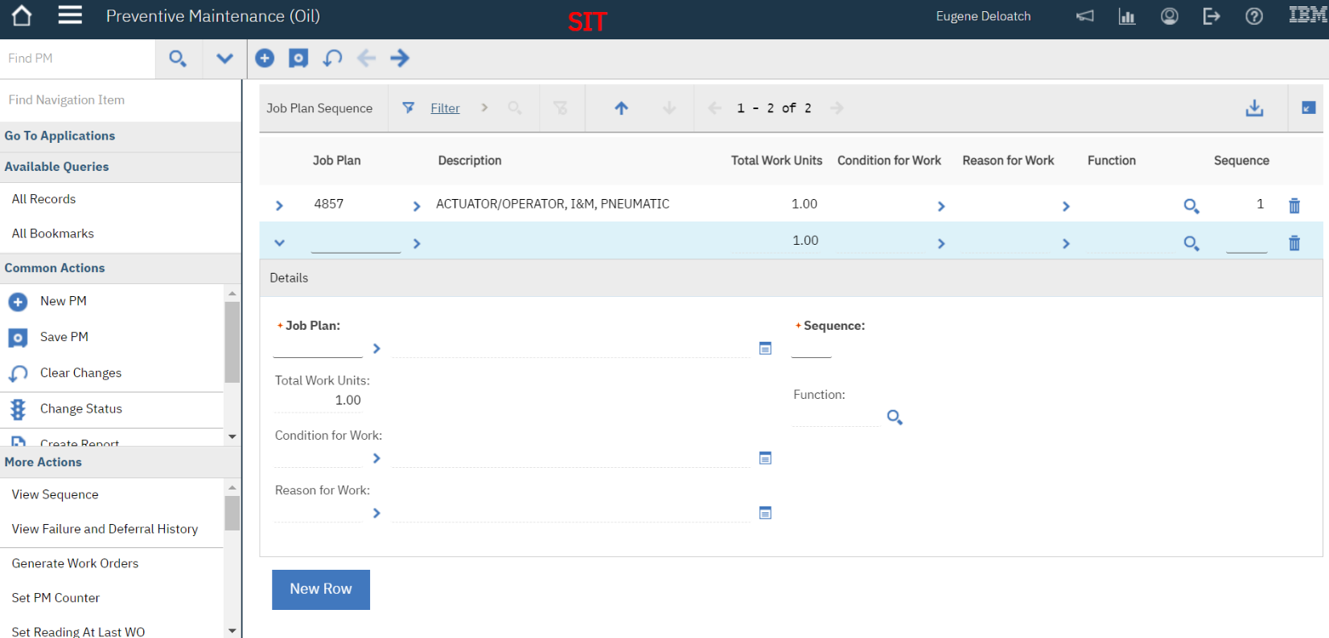
- Click the Job Plan Sequence tab and enter detail in the mandatory field.

Note: The mandatory field in the Job Plan Sequence tab is Job Plan.

- Click the PM Hierarchy tab and enter details in the required fields.
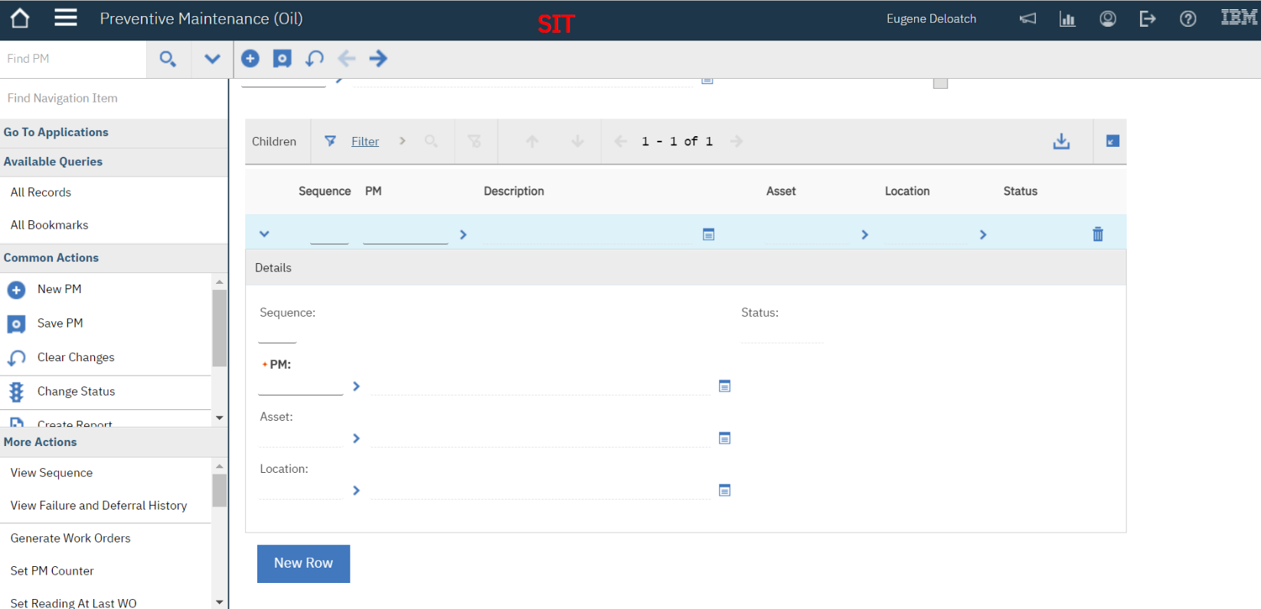

- Select the Regulations tab and click the Select Regulations button to add regulations.
